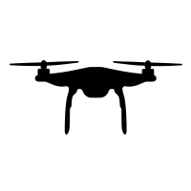

Eliminate background high frequency noise by LPF

Calculate the probability of presence of speech in the noisy input using VAD

Estimate the best match of the noise signal from the noise pool using GCSA

Temporal subtraction to remove the noise from the input noisy signal

Obtain the M-channel STFT to estimate the Cross-Correlation in frequency domain

Identify the peak in the phase plot

Estimate the Azimuth and Elevation angle using GCC-PHAT algorithm

Clean Speech

Wind noise and ego noise generated by rotating motors and propellers

M-channel audio inputcontaminated by ego motor and wind noise

Noise Pool